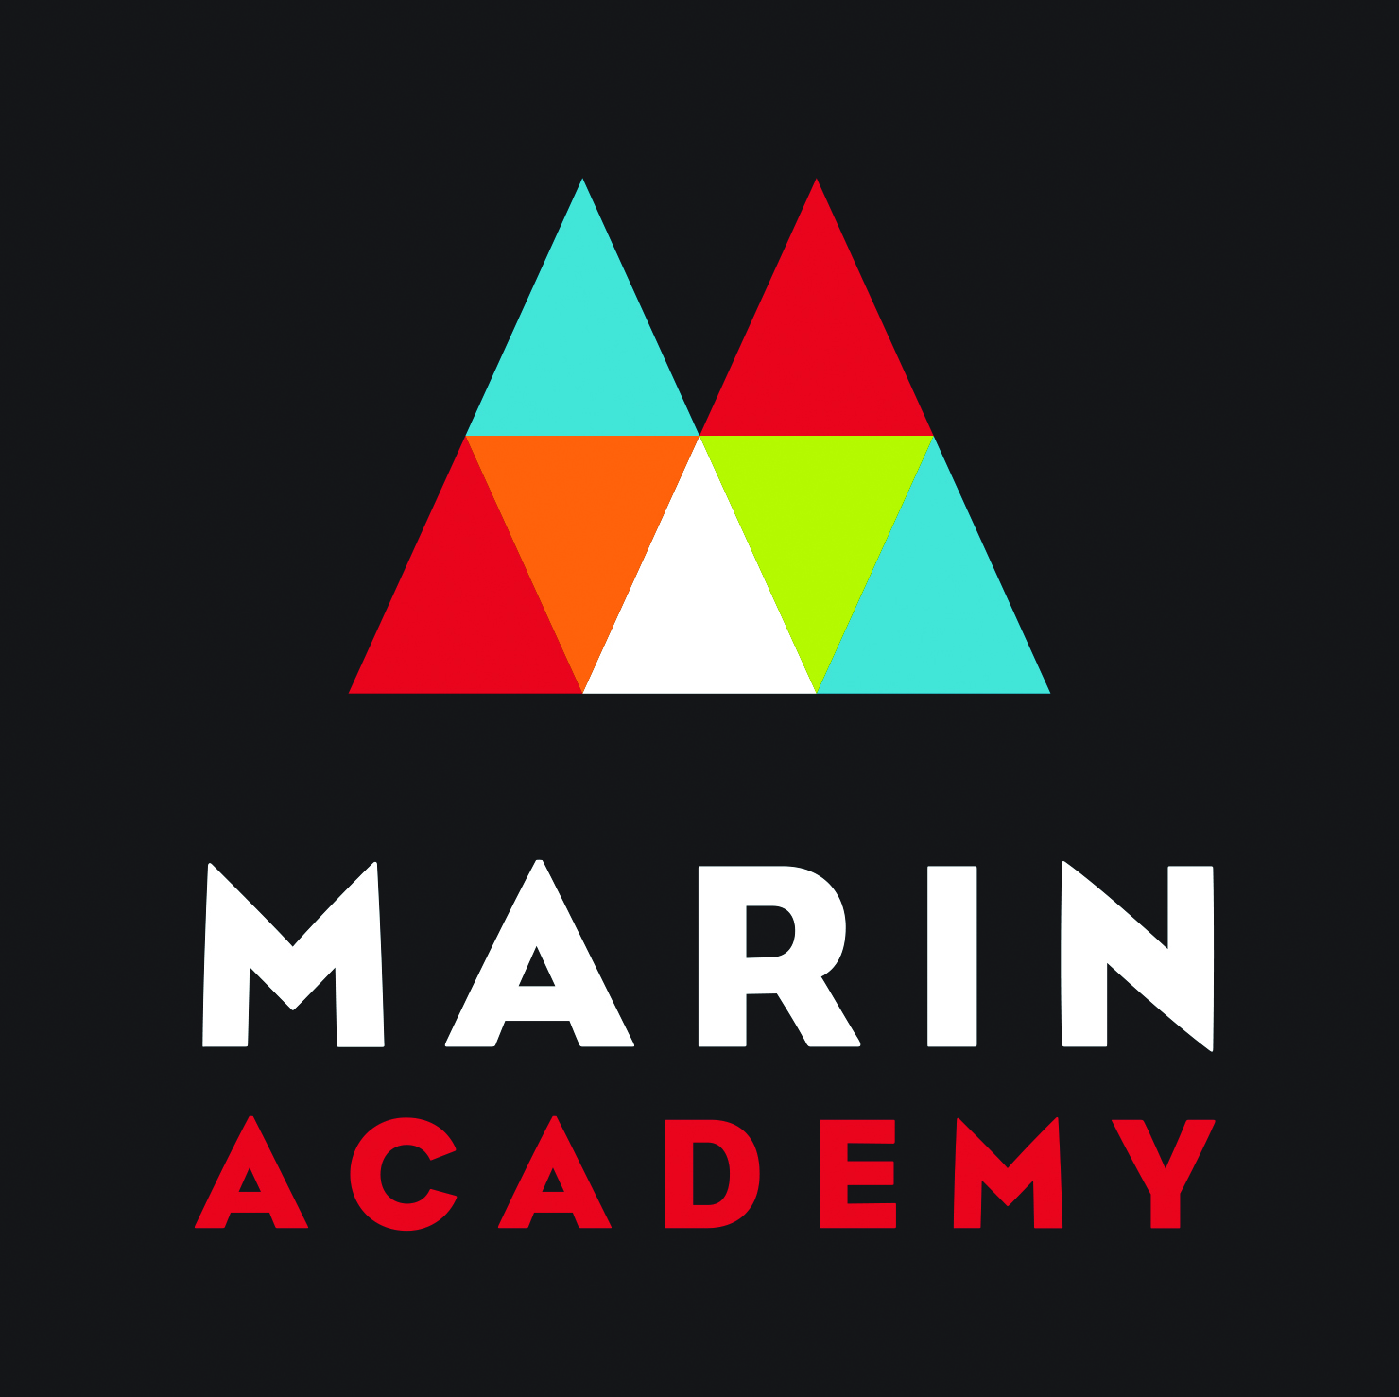

Marin Academy Youth Grants Board

Grant Proposal Application 2018-2019

Receive up to $1000 for service and social justice projects
in your school or community

Mission: To support and provide funding for youth-led service and social justice projects that encourage community engagement and stewardship
Vision: To promote youth leadership and civic engagement in an effort to improve the communities around us

HOW TO APPLY
Please email completed grant proposals to Marin Academy Youth Grants Board at grants@ma.org by
Friday, February 1, 2019.

Questions? Contact the Marin Academy Youth Grants Board at grants@ma.org.
Marin Academy
1600 Mission Ave, San Rafael, CA, 94901.

MAYGB ©2015. Please do not use or duplicate without permission.
Project Criteria
- Requests can be made for up to $1,000, based on a proposed budget.
- Applications must be completed by a youth leader (not an adult ally or sponsor).
- Projects should be youth-led, build youth skills and talents, and help improve Bay Area communities.
- If the project has previously received a grant from MAYGB, the application must reflect a new dimension to the project to received a new grant.
- Though we value international service and charity, service trips and study abroad programs, we do not fund these sorts of projects. Projects should address social justice and access issues and needs that face our local communities.
- Projects must have an adult sponsor (teacher, advisor, non-profit coordinator, etc).
- Grant recipients must maintain and submit a final report of project activity (for example; expenses, activities, number of people served/ services provided and a summary of impact). Projects that do not turn in reports will be ineligible for future funding.
- Please keep in mind that this application is the main way we will get to know you and your project. Be sure to turn in a complete application.
On a separate sheet of paper, please concisely respond to the following prompts in Parts 1 & 2 (4 pages max.):
PART 1:
- Project Name
- Name of Primary Youth Applicant (include Phone Number & email)
- Name of Adult Sponsor (include Work Phone Number & email)
- Names, Phone Numbers and Email Addresses of all youth involved in project application
- Explain how you hear about this grant.
PART 2 (Approximately 200 words or fewer per question):
- What is the purpose or goal of your project and how will it be accomplished?
- How long has/will your project be active?
- How will your project impact the Bay Area community and/ or specific individuals?
- How will your adult sponsor be affiliated or support your project?
- How will your project develop and/or expand youth skills?
- Reapplicants only: If you have previously received a grant from MAYGB, how will this new grant advance or address a new dimension to your project?
PART 3:
- Include a month-to-month projected timeline of your project along with a budget. Feel free to use the attached budget template or create your own. Please keep in mind that we want to fund the most vital parts of your project. We do not fund applicant’s travel expenses, stipends, t-shirts, food, etc. If possible, please provide online links for any products being purchased, in order to demonstrate the projected costs.
- Provide a short letter of recommendation from an adult sponsor (not a parent/guardian).
- OPTIONAL (but strongly encouraged): Attach a two to three minute video “pitch” for your project, explaining who you are, why you are passionate about the project, who it will benefit, and, in short, why it is worthy of receiving a grant.

Your Projected Budget
What do you need & what it is for | Cost for Each Item | In-Kind Donation | Amount you are asking MAYGB for

Example Projected Budget- (Summer enrichment class led by high school student for under-resourced middle school students)
What do you need & what it is for | Cost for Each Item | In-Kind Donation | Amount you are asking MAYGB for
Books | $9 (14 books total) |  | $126
Pencils | $7 (2 24-pencil pack) |  | $14
Notebooks | $2 (15 notebooks total) |  | $30
Whiteboard pens | $6 (2 packs total) |  | $12
Field trip to Stanford University | $12 per student for transportation  $8 per student for lunch |  | Bus Transportation: $192  Lunch: $112
Classroom space | $25 per hour (6 hours total) | $150 | (none)
Total |  | $150 | $486

